**DAILY ONLINE ACTIVITIES SUMMARY**

|  |  |  |  |  |  |  |  |
| --- | --- | --- | --- | --- | --- | --- | --- |
| **Date:** | **11/06/2020** | | | | **Name:** | **Vandana E V** | |
| **Sem& Sec** | **8th semA sec** | | | | **USN:** | **4AL15CS103** | |
| **Online Test Summary** | | | | | | | |
| **Subject** | | **SMS** | | | | | |
| **Max. Marks** | | **60** | | **Score** | | **60** | |
| **Certification Course Summary** | | | | | | | |
| **Course** | **Introduction to cyber security** | | | | | | |
| **Certificate Provider** | | | **Great Learning Academy** | **Duration** | | | **7hrs** |
| **Coding Challenges** | | | | | | | |
| **Problem Statement: 1) Python3programtoprinttheMinimumStringlength** | | | | | | | |
| **Status: Completed** | | | | | | | |
| **Uploaded the report in Github** | | | | **Yes** | | | |
| **If yes Repository name** | | | | **Vandana** | | | |
| **Uploaded the report in slack** | | | | **Yes** | | | |

Online Test Details:

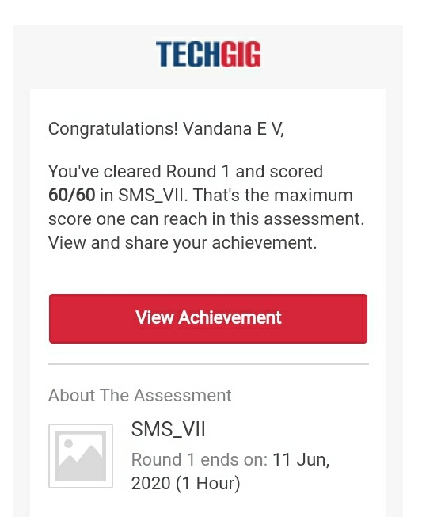

Certification Course Details:

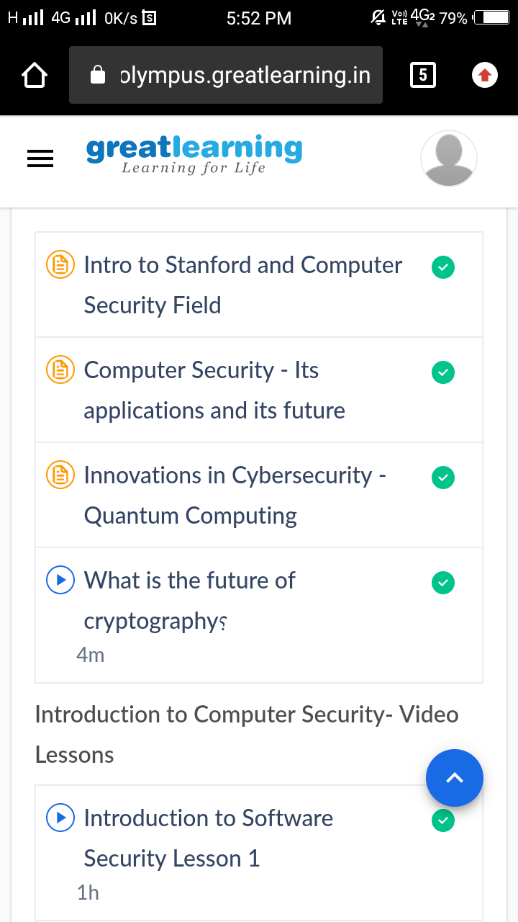

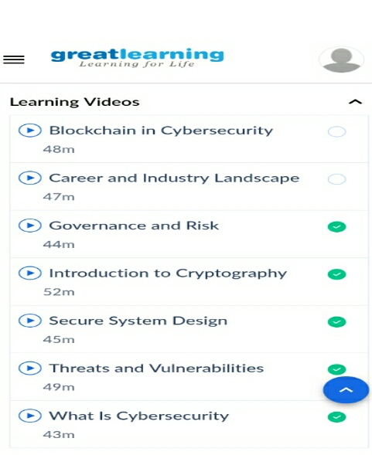

Coding Challenges Details:

1)

test_list=['python','java','c++']

print("Theoriginallist:"+str(test_list))

res=min(len(ele)foreleintest_list)

print("Lengthofminimumstringis:"+str(res))